Strategy Mapper Configuration Guide

Table of Contents

Introduction 3
Account Mapper 4
Templates 4
Details 4
Checklist 9
Pick List Values 11
Opportunity Mapper 13
Templates 13
Details 13
Related 17
Sales Coaching 18
Opportunity Milestones 20
Pick List Values 22
Meeting Mapper 23
Templates 23
Meeting Template Details 23
Meeting Button Configuration 24
Meeting Template Button Configuration Examples 27
Meeting Insights 29
Meeting Prerequisites 30
After Actions Review 30
Follow Up 31
Objectives 32
Pick List Values 32

Introduction

Strategy Mapper is comprised of three integrated solutions, Account Mapper, Opportunity Mapper and Meeting Mapper and is designed to allow each organization to configure it to best fit its requirements. Though you can use Strategy Mapper with very little configuration, it’s highly recommended that you take the time to go through this document and plan the configuration. The amount of time required will vary from organization to organization, but on average, most will get through the initial configuration in a matter of a few hours. As Strategy Mapper evolves in the organization, further configuration can be done to refine its use.

There are two primary configurable areas, Templates and Pick List Values.

Templates are used so you can configure the three components in Strategy Mapper, Account Mapper, Opportunity Mapper and Meeting Mapper. For example, you may create templates for Account and Opportunity Mapper to follow the segmentation of your customer base by having templates for larger accounts and smaller accounts. You can then create templates for the types of meetings you have with each of these accounts like discovery meeting or contract meeting.

The Pick List Values allows you to provide Strategy Mapper users preconfigured dropdown lists to select from in Account Mapper, Opportunity Mapper and Meeting Mapper. There are currently over 20 objects, but not all of the objects listed here require configuration. In addition, some of the objects have multiple fields to configure. You can enter in your configuration in the last column, then cut and paste into corresponding object and fields in “Add Picklist Values” in the application.

Account Mapper

Templates

There are two parts to an Account Plan Template Details and Related.

NOTE – There is no limit to the number of templates you can create.

NOTE – when change to the above listed text boxes are made to a template, account plans already using the template will not be affected. The change will only affect new plans.

Details

There are seven sections in the Detail page.

Details - displayed on the Details (initial page displayed in the account plan) (figure 1 & 2).

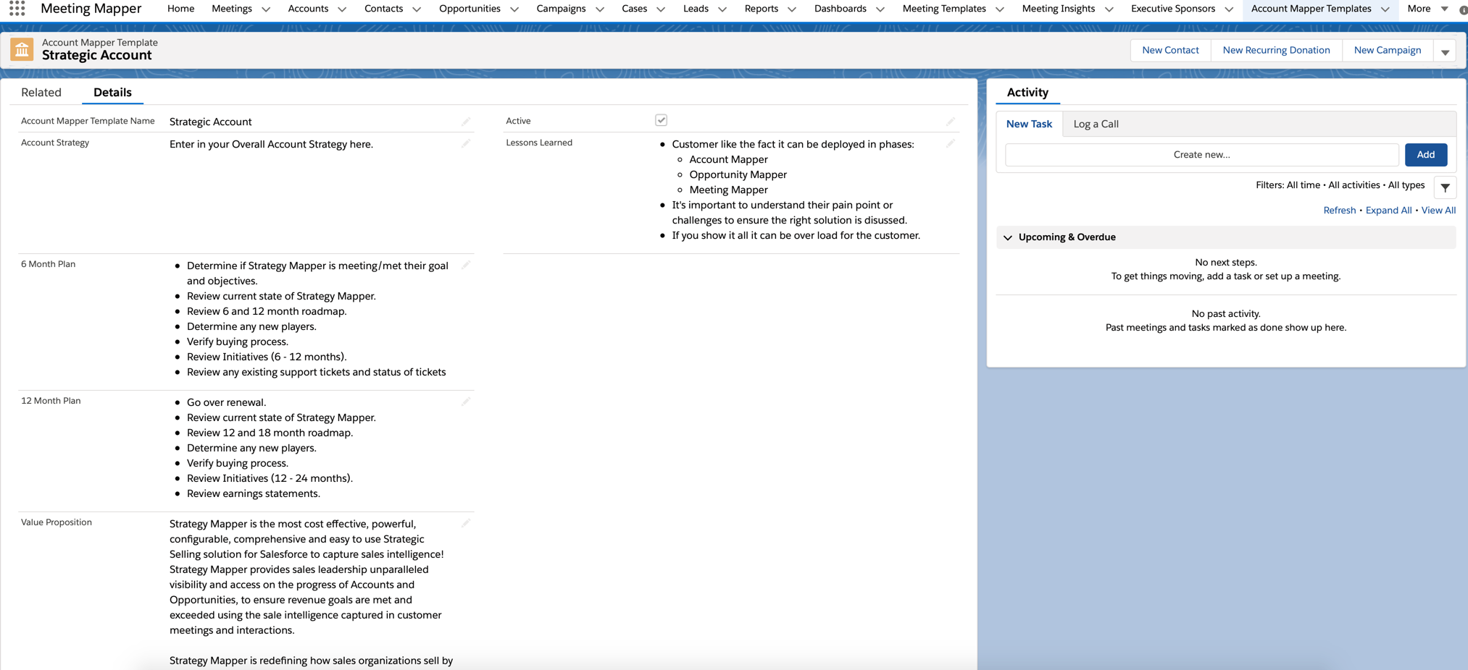
Figure 1
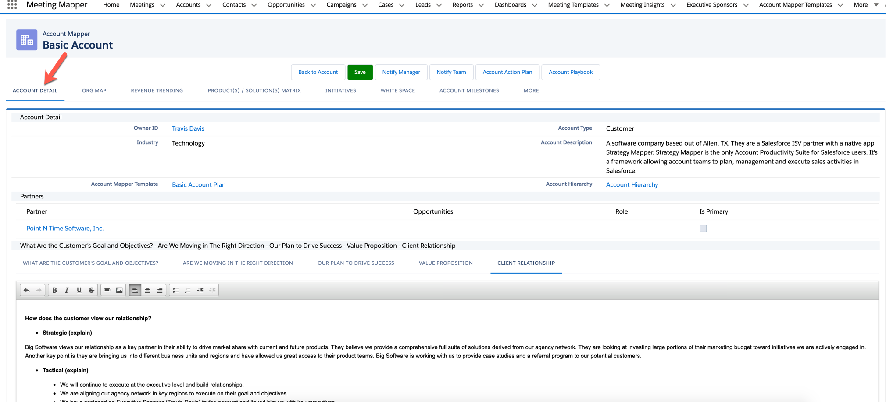
Figure 2

Labels – allow you to change the default name of the following (figure 3): Below are guidelines for the content of the sections in the Detail page. However, this is determined on your configuration and labeling of the individual sections.

- Account Strategy - provide a narrative the overall account strategy for this type of account. This is a rich text field and can include things like standard activities to accomplish, links to useful information, standard account team members, etc.
- 6 Month Plan - provide a narrative of the short-term account plan. This is a rich text field and can include things like standard activities to accomplish, links to useful information, standard account team members, etc.
- 12 Month Plan – provide a narrative of the longer-term account plan. This is a rich text field and can include things like standard activities to accomplish, links to useful information, standard account team members, etc.
- Value Proposition – provide the user the stated value proposition your company and products/solutions provide the customer. Here is also a great place to include any customer quotes.
- Lesson Learned - provide lessons learned from similar accounts to give the users an example of the type of information needed in this section.

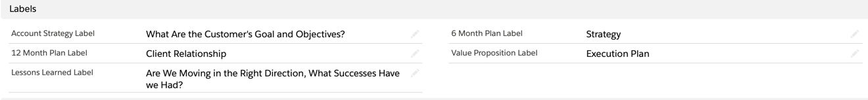
Figure 3
Tabs – allows you to determine the tabs (pages) to display in the account plan (figure 4 & 5).

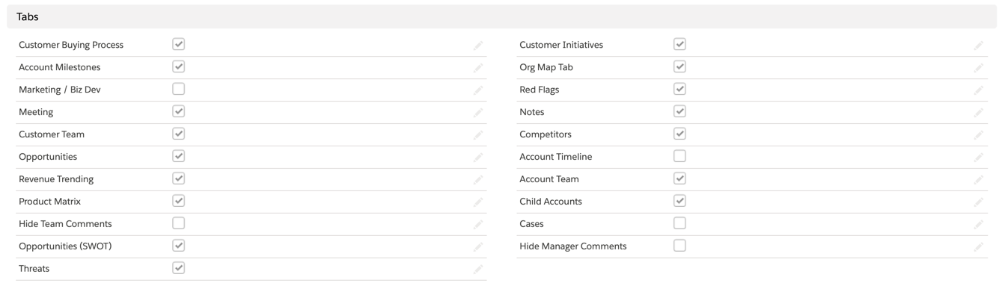
Figure 4
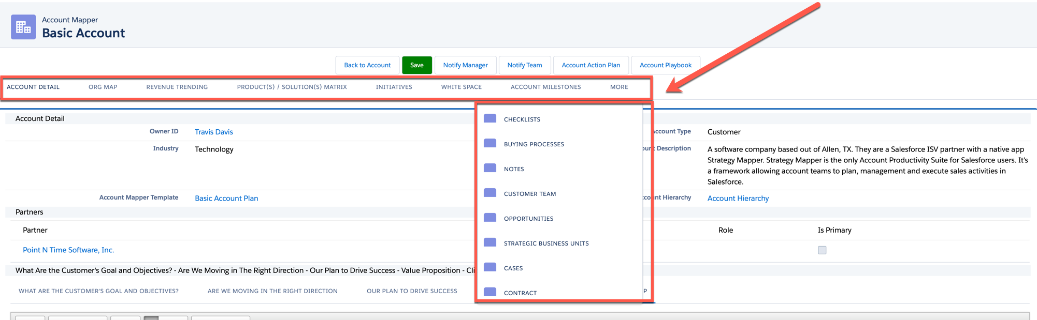
Figure 5
Buttons - allows you to determine the button to display in the account plan (figure 6 & 7).

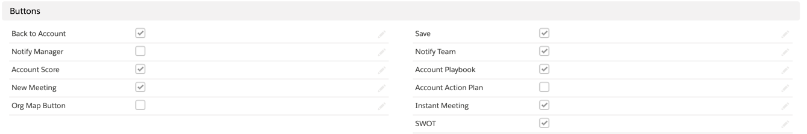
Figure 6

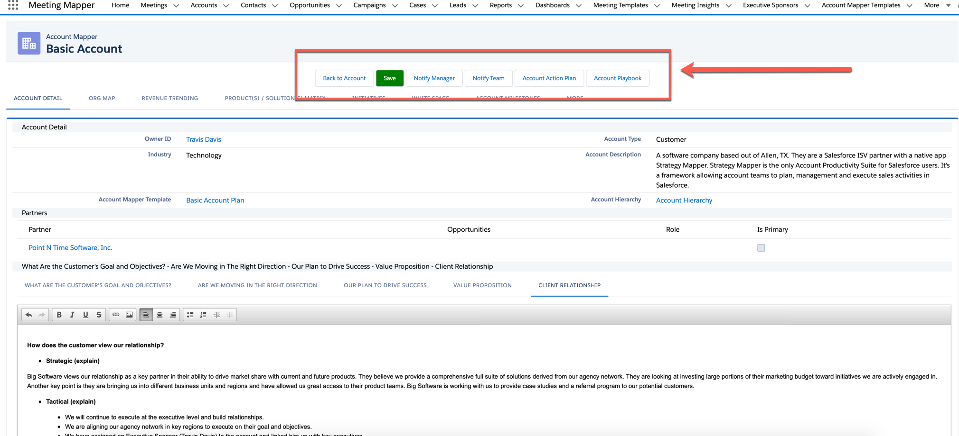
Figure 7
Hide Score Buttons - allows you to determine sections to display in Account Score (figure 8 & 9).

Figure 8
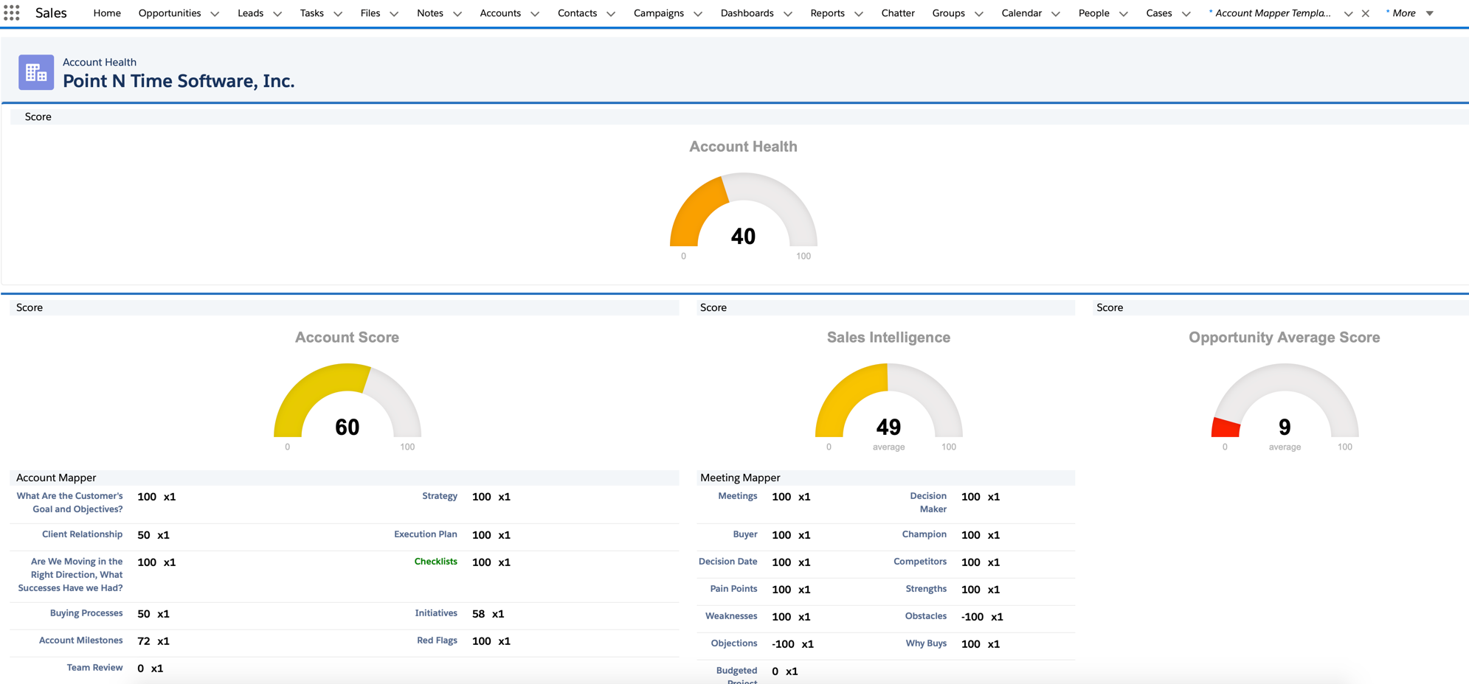
Figure 9
SWOT Configuration - allows you to determine sections to display in the SWOT (figure 10 & 11).

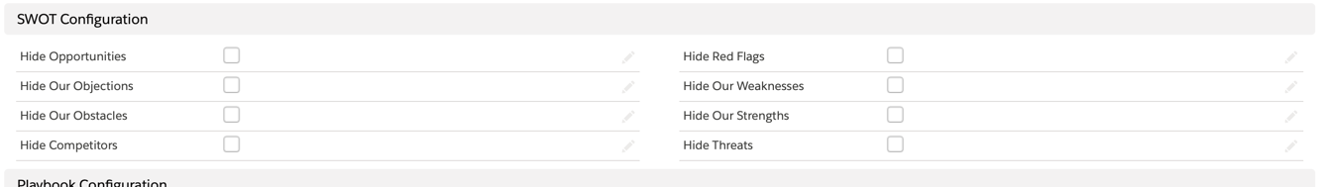
Figure 10
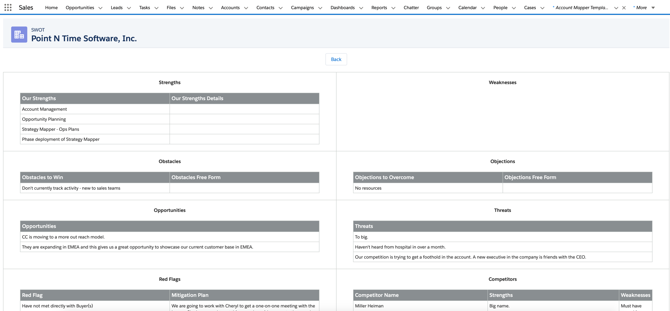
Figure 11

Playbook Configuration - allows you to determine sections to display in the Account Plan (figure 12 & 13). By default all the sections are displayed.

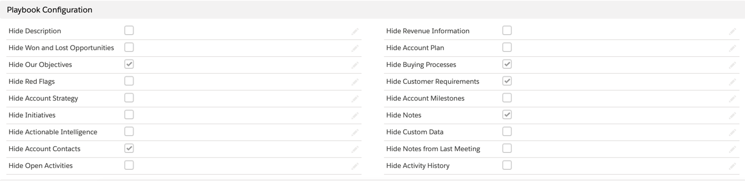
Figure 12
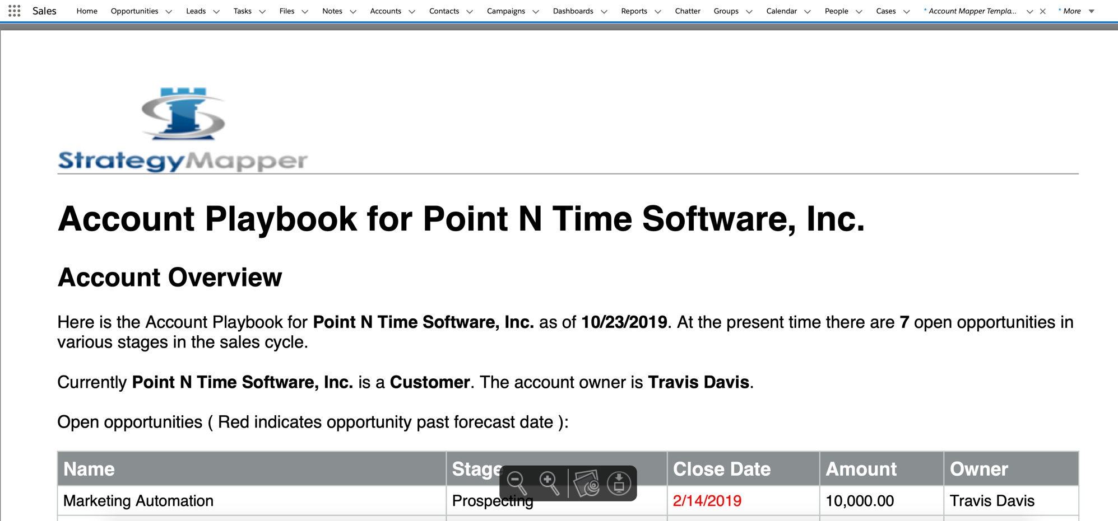
Figure 13
Active – once you have completed the template and want to make it available to your users, click on Active.

Checklist

Checklist is a generic list of items that should be completed to be successful in an account. They are displayed in the Checklist page of the account plan (figure 14 & 15).

NOTE – There is no limit to the number of Checklist items you can create.

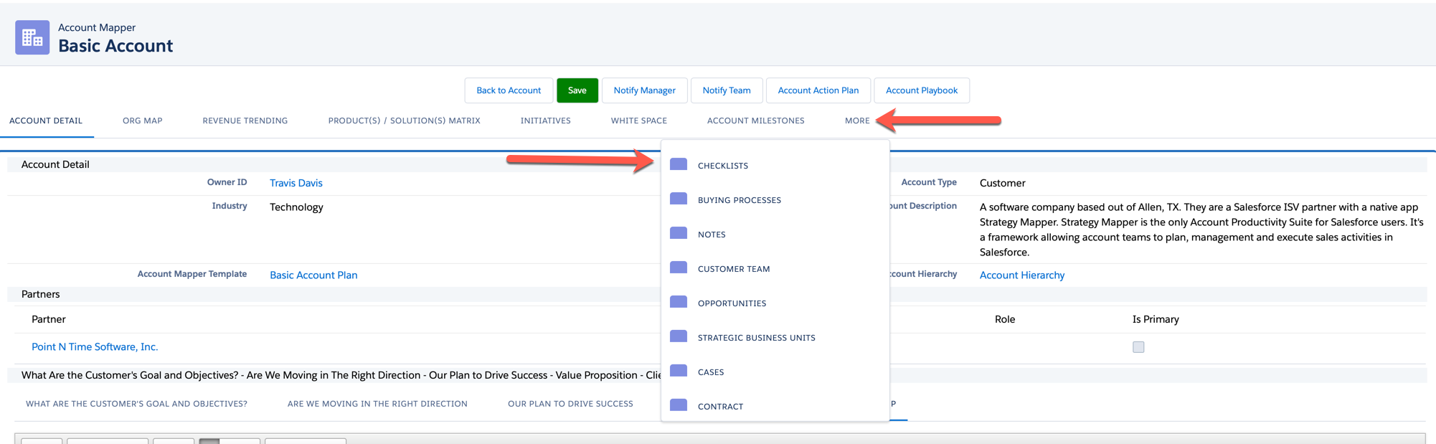
Figure 14
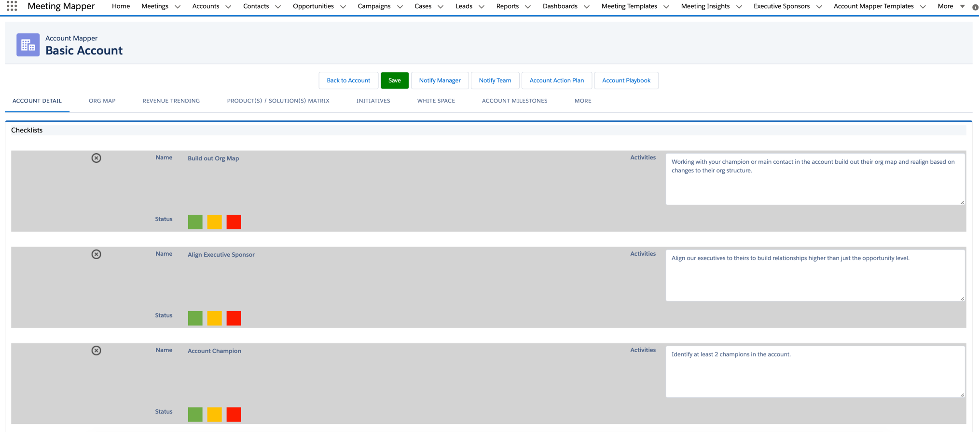
Figure 15
A checklist item is comprised of the Checklist Name – Coaching (displayed as Activities in the plan), Gate (significant item) and Order (where in the list is it displayed) (figure 16).

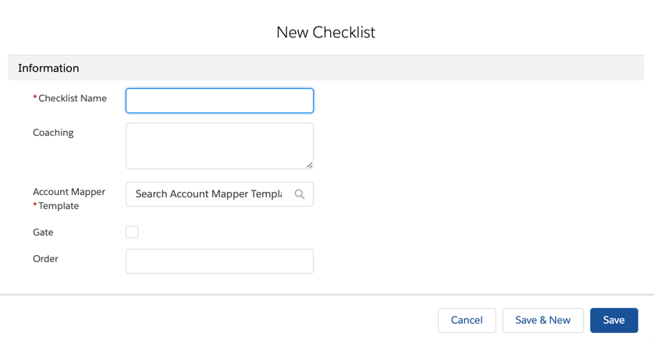
Figure 16

Pick List Values

The following picklist values are default values and examples of what can be added based on your business requirements. Add your values in the Your Configuration section of the table below. They can be cut and pasted into Strategy Mapper.

NOTE – Items in red should not be modified. Items lined through are not used in the current version and are reserved for later versions.

Account Mapper Picklist Configuration
Object | Field | Default Values | Your Configuration
Account Milestones | Title | Schedule an Executive Briefing  Schedule 6 - 12 Roadmap  Schedule Account Review Meeting  Schedule a Health Check  Schedule an initial meeting
Customer Buying Process | Process | Identify the Problem  Review Options  Bring in top 3 vendors  Pilot/Trial selected vendor  Sign contracts  Deploy Solution
Customer Initiatives | Initiative | Sales Enablement Platform  BI/Analytics  Cloud  Mobile  Digitization/Marketing Automation  Infrastructure/Data Center  ERP  Security  Business Critical Application  CRM  Networking/Voice/Data Communications  Sales team retention  Customer Support  Customer Satisfaction  Create a Loyalty Program  Security and Compliance in the Cloud  Encryption Key Management
 | Time Frame | Current FY - Q1  Current FY - Q2  Current FY - Q3  Current FY - Q4  Next FY – Q1  Next FY – Q2  Next FY – Q3  Next FY - Q4
Red Flag | Red Flag | Difficult to get access to Decision Makers.  Their legal process is very difficult and takes normally 30 - 45 days.  They are very geographically distributed so getting to each corporate location does take time and planning  New Challenge

Opportunity Mapper

Templates

There are two parts to an Opportunity Plan Template Details and Related.

NOTE – when changes are made to a template, opportunity plans already using the template will not be affected. The change will only affect new plans.

NOTE – These is no limit to the number of templates you can create.

Details

There are six sections within the details page. The sections below are displayed on the Details (initial page displayed in the opportunity plan) (figure 17)

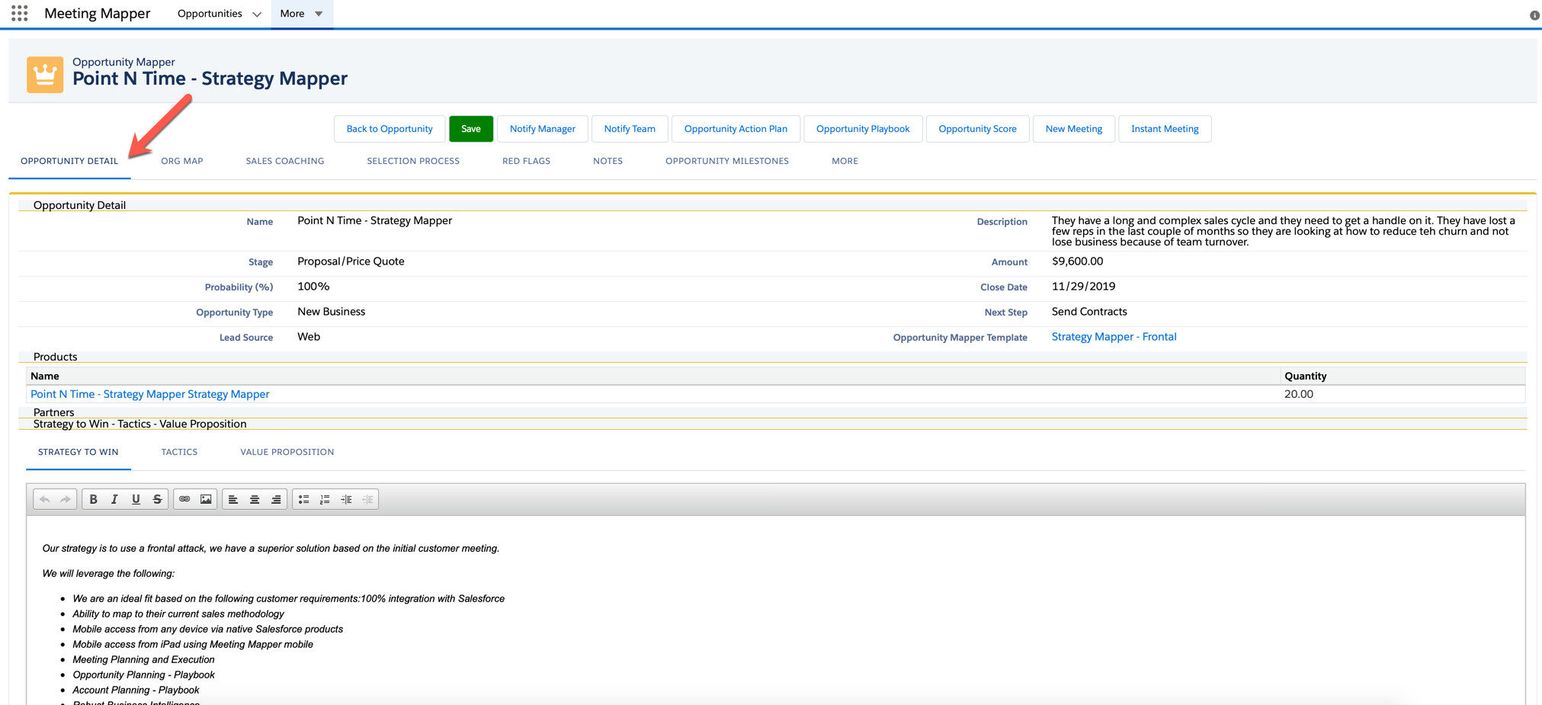
Figure 17

The Details section as three section (figure 18):

Opportunity Mapper Template Name – provide a descriptive title, so users select the correct template based on the opportunity. For example; Technology Frontal, this template would be used to build strategic plans for opportunities that are in the technology space where the strategy is Frontal (frontals are used when you have a far superior product, you are the incumbent).

Strategy to Win – provide stated strategy to win in this type of opportunity.

Tactics – provide the tactics used to win this opportunity based on the strategy.

Value Proposition – provide the user the stated value proposition your company and products/solutions provide the customer. Here is also a great place to include any customer quotes.

Active – once you have completed the template and want to make it available to your users, click on Active.

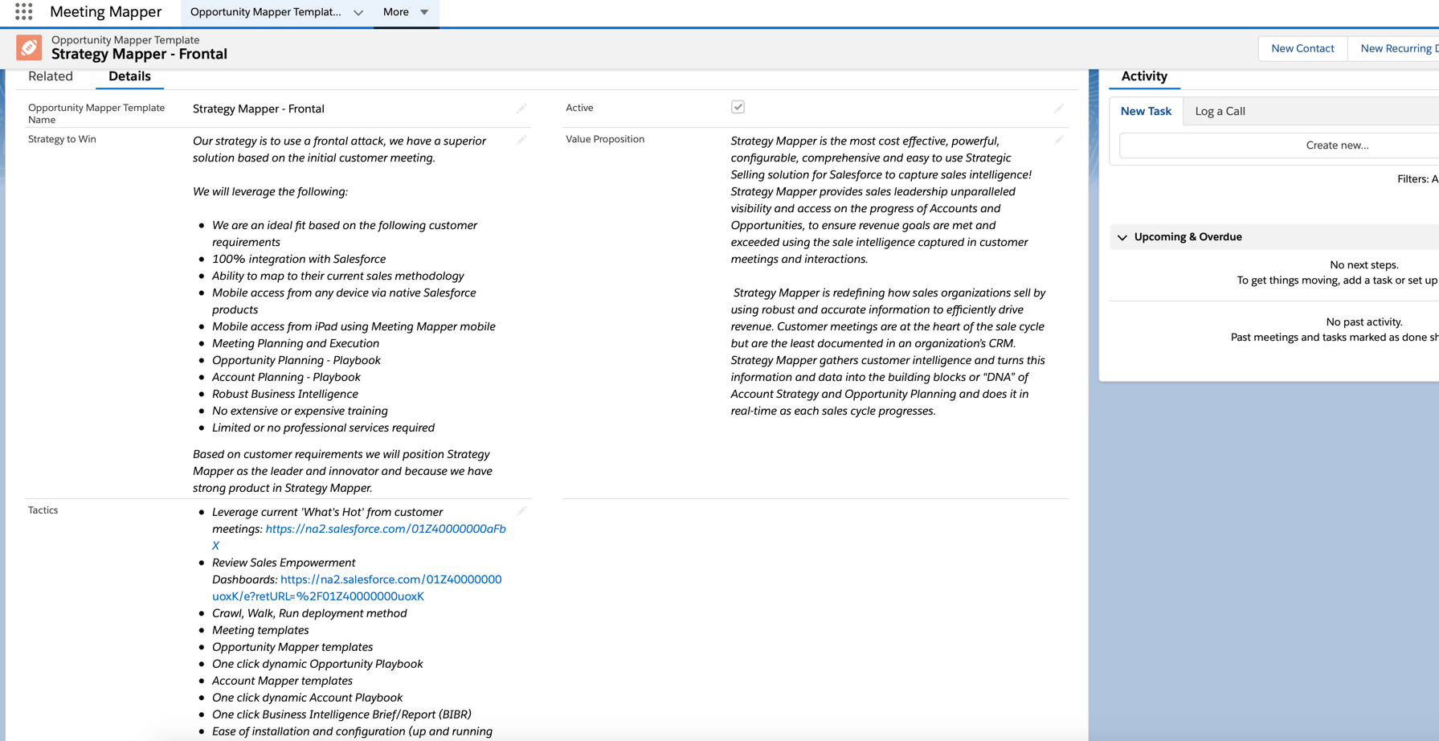
Figure 18
The other sections in the details page are:

Tabs – allows you to determine the tabs (pages) to display in the opportunity plan (figure 19 & 20).

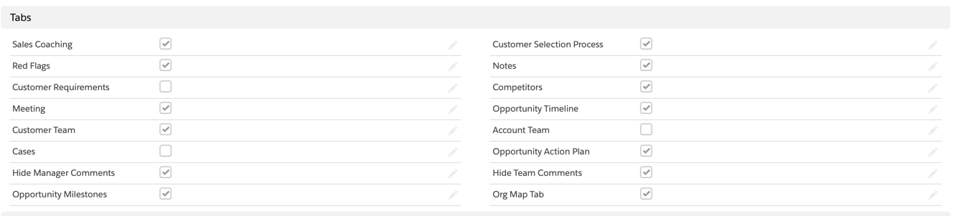
Figure 19
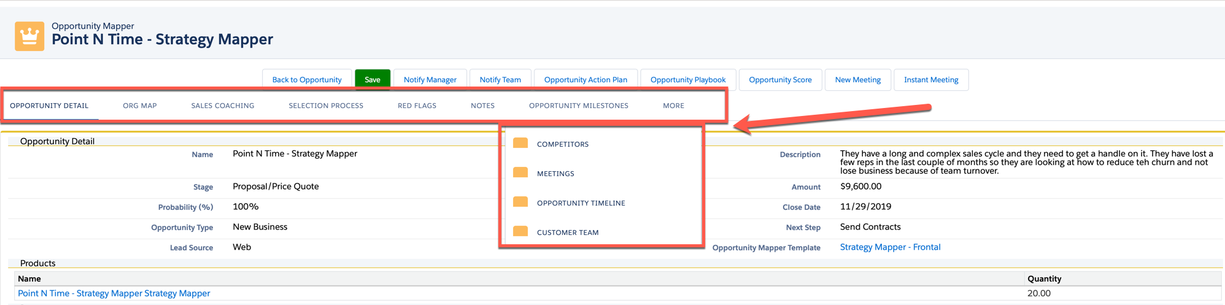
Figure 20
Buttons - allows you to determine the button to display in the opportunity plan (figure 22 & 23).

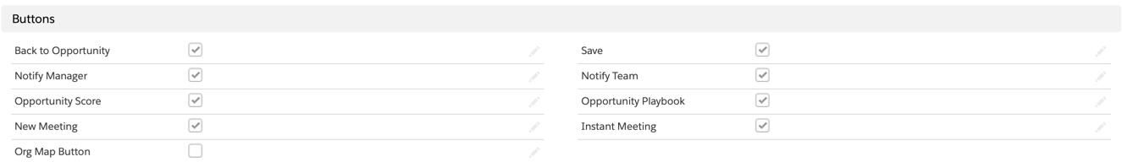
Figure 21

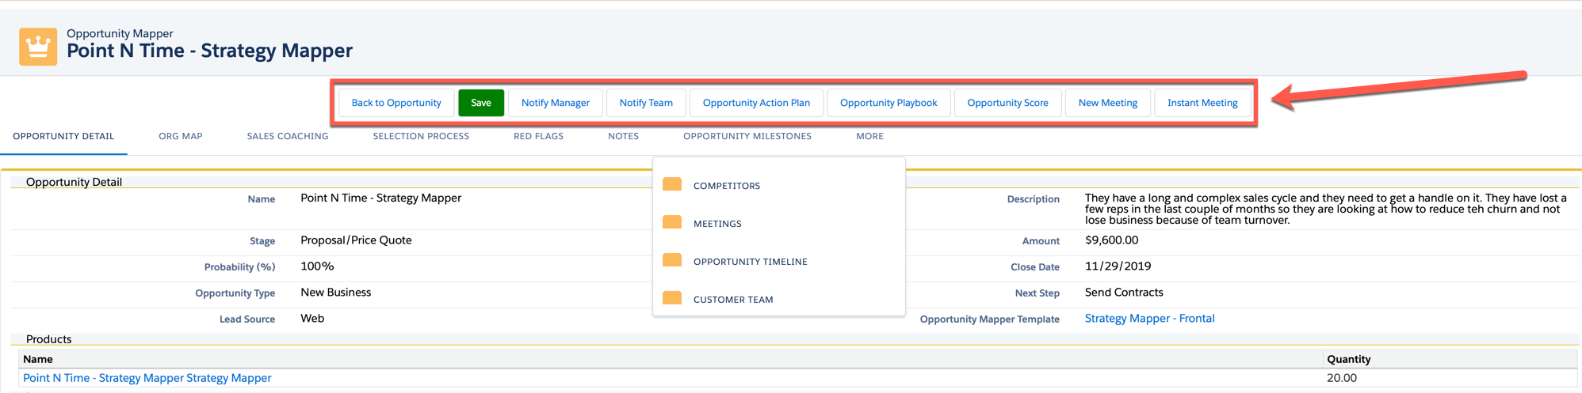
Figure 22
Hide Score Board - allows you to determine sections to display in Account Score (figure 24 & 25).

Figure 23
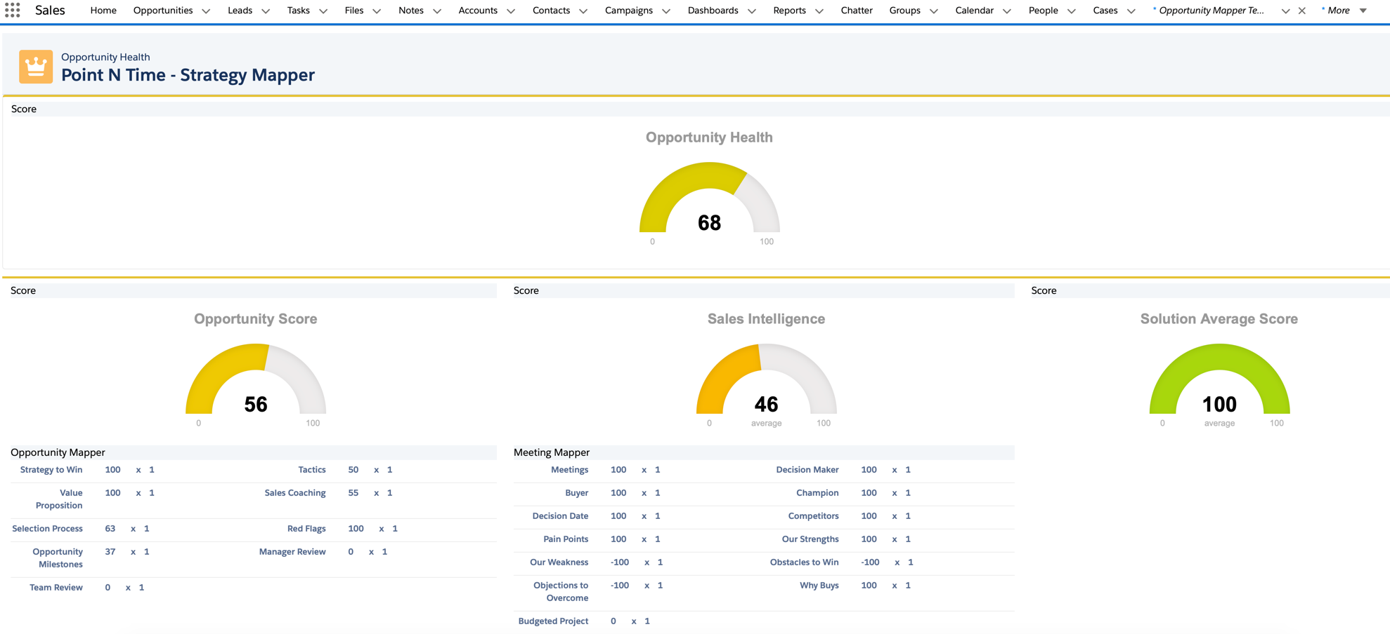
Figure 24
Playbook Configuration - allows you to determine sections to display in Opportunity Playbook (figure 25 & 26). By default all the sections are displayed.

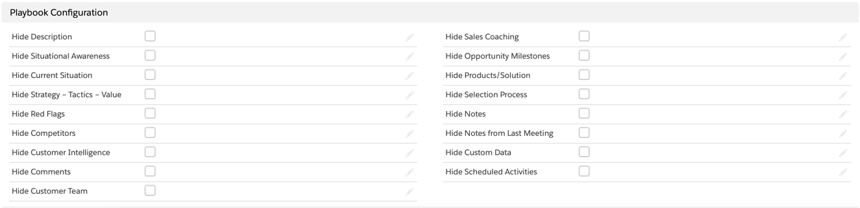
Figure 25
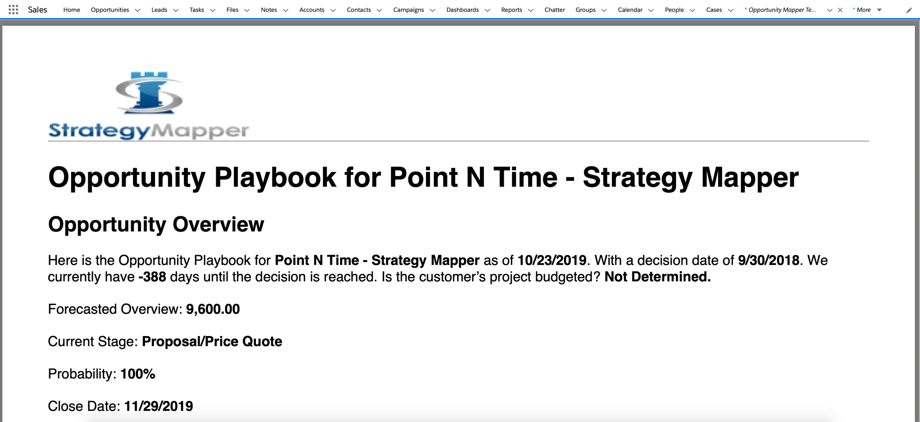
Figure 26

Related

Related has three sections (figure 27):

Opportunity Mapper Name – Opportunities that are using the template.
Sales Coaching – List the stages of the opportunity and any coaching advice provided to the users.
Opportunity Milestones – Individual milestones that must be completed in the opportunity to win.
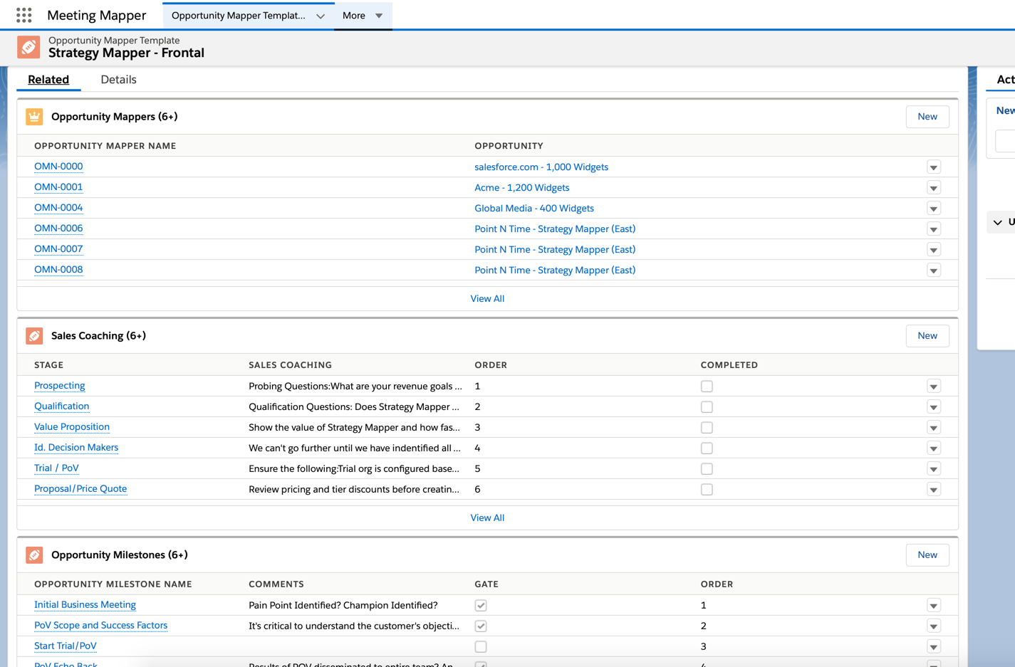
Figure 27

Sales Coaching

Sales Coaching is displayed in the Sales Coaching page of the opportunity plan (figure 28).

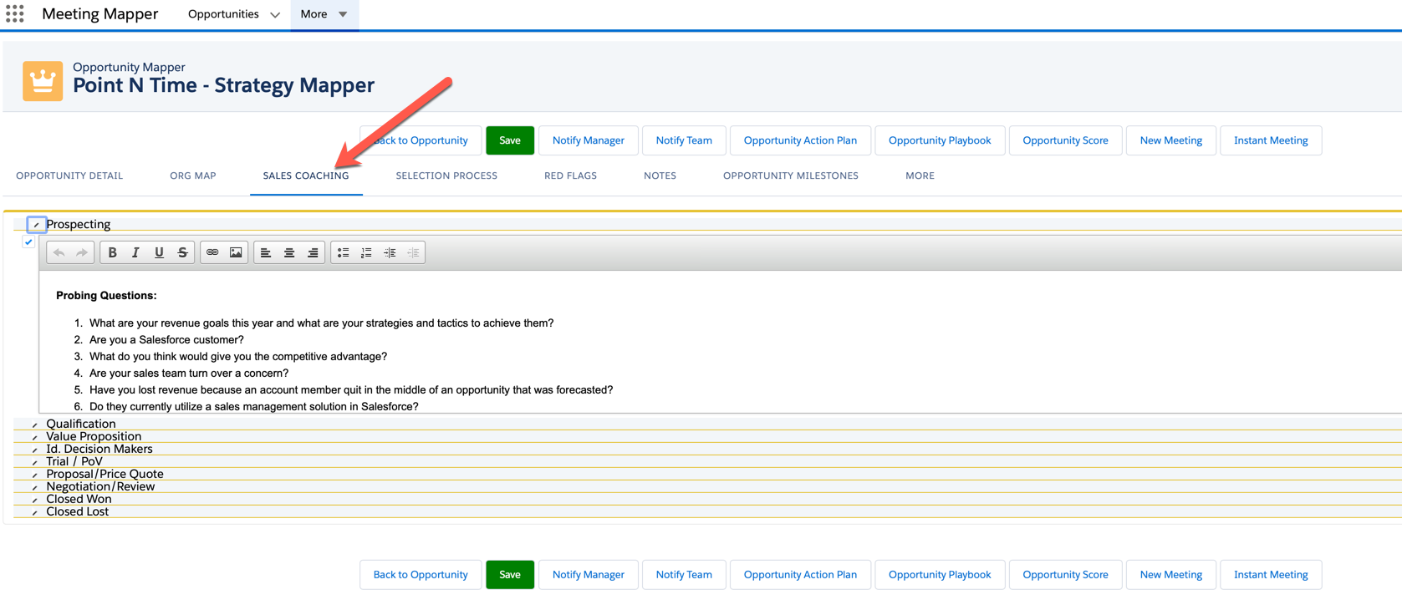
Figure 28

By default, Strategy Mapper pulls the stages defined in Salesforce (figure 29). Coaching can be added per stage. It is critical that you put the stages in the proper order, if this is not completed the stages will be viewed in the Opportunity Plan in alphabetical order (figure 30).

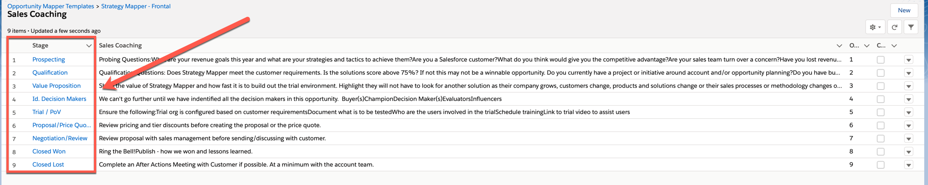
Figure 29

Best Practice – Point N Time Software includes information in each of the stage’s Sales Coaching section that can assist the user in moving the deal along. For example, in the Prospecting stage you might want to include questions to ask the customer, add links to video or other material that may be useful to the user.

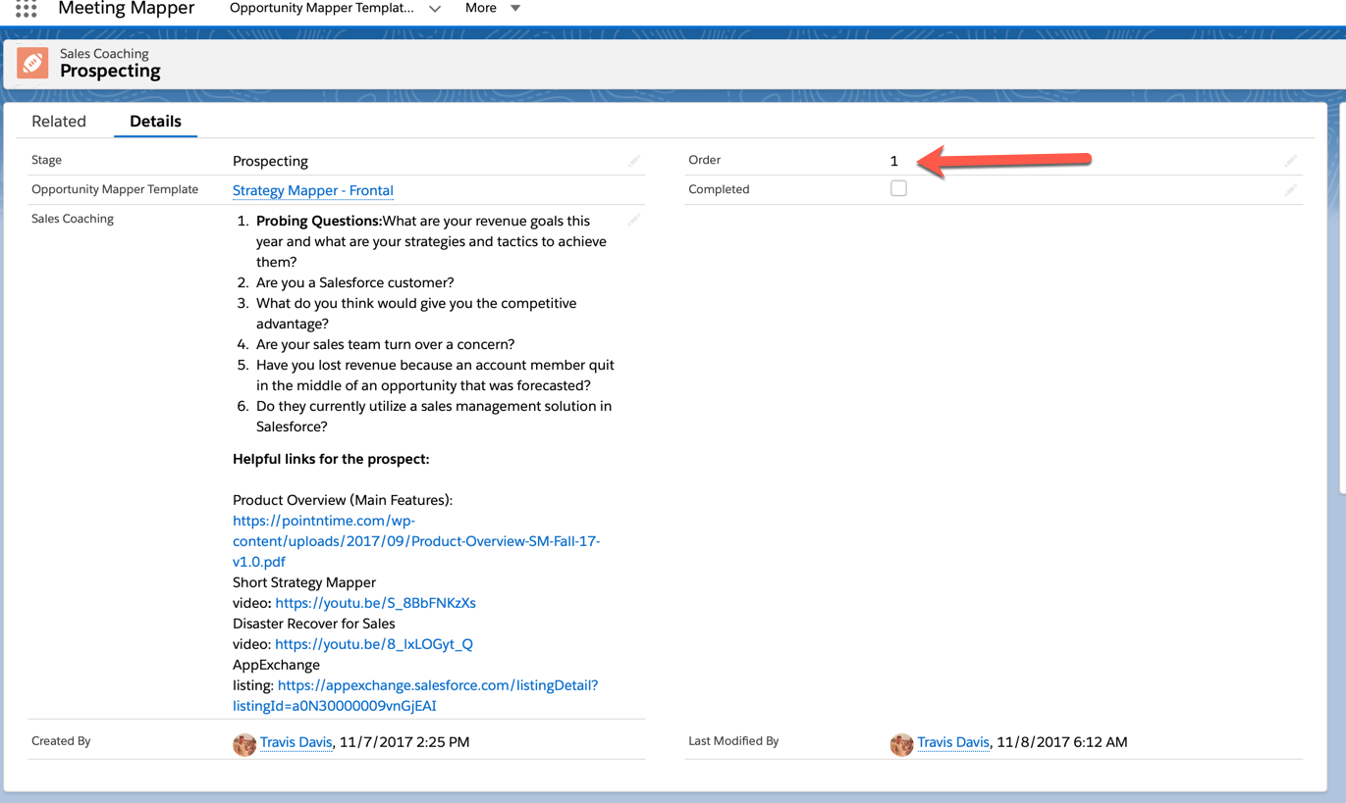
Figure 30

Opportunity Milestones

Opportunity Milestones are displayed on the Opportunity Milestones page in the opportunity plan (figure 31).

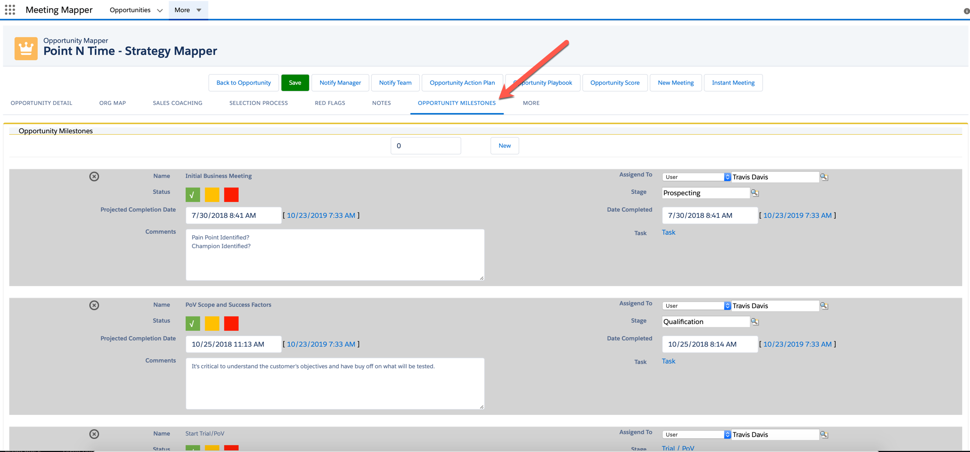
Figure 31
Opportunity Milestones allow you to build out a sales process in a template. You can also specify that a milestone is a “Gate”. A gate is a critical milestone that must be completed before moving to the next milestone in the opportunity.

Opportunity Milestones are not required, and the Opportunity Milestone tab will not be displayed, in the event there are no Opportunity Milestones created.

NOTE – Milestones that are configured as a gate will be in bold text in the Opportunity Milestone tab in the opportunity plan. If a milestone gate is marked in red (not completed) the Opportunity Milestone tab will be colored Red, signifying this gate as not been met or completed.

There are 4 sections in the Opportunity Milestone Edit. They are:

- Opportunity Milestone Name – The name of the milestone.
- Gate – select if this milestone is gate.
- Opportunity Mapper Template – no configuration needed.
- Order – order in which the milestone is displayed in the Opportunity Milestones tab in the opportunity plan. It is critical that you put the milestones in the proper order, if this is not completed, the stages will be viewed in the Opportunity Plan in alphabetical order (see figure 32).

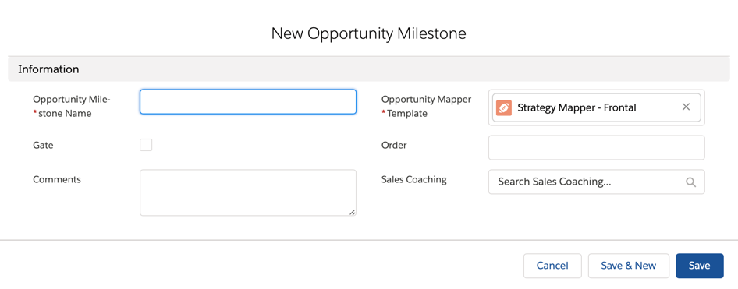
Figure 32

Pick List Values

The following picklist values are default values and examples of what can be added based on your business requirements. Add your values in the Your Configuration section of the table below. They can be cut and pasted into Strategy Mapper.

Opportunity Mapper Picklist Configuration
Object | Field | Default Values | Your Configuration
Customer Buying Process for Opportunity | Process | Identify the Problem  Review Options  Bring in top 3 vendors  Pilot/Trial selected vendor  Sign contracts
Red Flag for Opportunity | Red Flag | Difficult to get access to Decision Makers.  Their legal process is very difficult and takes normally 30 - 45 days.  They are very geographically distributed so getting to each corporate location does take time and planning

Meeting Mapper

Templates

Meeting Mapper templates are used to configure the meeting page display and functionality. Meetings can be linked to several standard Salesforce.com objects (Accounts, Campaigns, Cases, Contacts, Leads, and Opportunities). At least one template must be created for each object that will be used with Meeting Mapper.

The meeting template is comprised of the following sections (figure 33):

Meeting Template Details

NOTE – The only required sections to be completed is Meeting Template Name.

Meeting Template Name – descriptive name for the template that will help ensure users select the proper template for the meeting.

Meeting Prefix - typically a 2-character prefix used as categorization in report generation.

Goal – this is the stated goal of the meeting.

Related Object – if selected, you can specify what fields from the selected object to display in the meeting page allowing updates to that object's fields. For example, you can specify "Opportunity" and display "Stage" so it can be updated directly from the meeting page.

NOTE – If an object is not selected the user cannot select fields to update in the meeting page and will require the user to navigate back to the Salesforce object (e.g. Opportunity) to update fields.

Is Mobile Template – specifies this template is used for syncing with the Meeting Mapper mobile app - Only one template can per object (Account, Opportunity, etc) can have this selected.

Call Plan – the text entered here will pre-populate the "call plan" for every meeting using this template. This text will be displayed in a window when a meeting is created using this template

Internal Notes – text entered in the field will pre-populate the internal notes section of every meeting using this template.

Best Practice – Include any questions you want the user to ask in Internal Notes, this is a great place to add any additional information, best practices or other information useful for the user during the meeting.

Active – once you have completed the template and want to make it available to your users, click on Active.

Is a Quick Meeting - any template can have this designation - This allows users to quickly create a meeting. This quickly creates a meeting using the current time and a user specified meeting template.

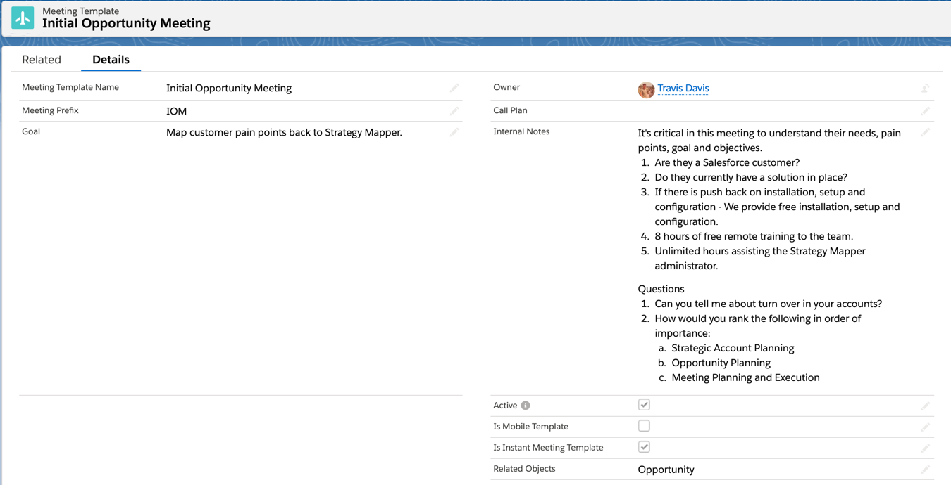
Figure 33

NOTE – These is no limit to the number of templates you can create.

NOTE – Users can change the Goal and Objectives in the meeting, this will not affect the template.

Meeting Button Configuration

This section allows you to specify which buttons and therefore functionality is available in each meeting created with this template. There are 23 buttons available buttons, 22 of which can be displayed on the meeting page. The “Sync Attendee Events” will prompt the user when a meeting is created asking if attendee events should be synced from a previous meeting. By default there are 17 buttons displayed along with Sync Attendee Events (figure 34).

Best Practice – When Strategy Mapper is initially deployed, it’s best to limit the functionality. This can help with user adoption. As the organization evolves the use of Strategy Mapper, additional buttons (functionality) can be added to the existing templates. The additional buttons will be displayed on all meetings using this template including past meetings.

Best Practice – When you have a template that is configured correctly, clone it to build additional templates.

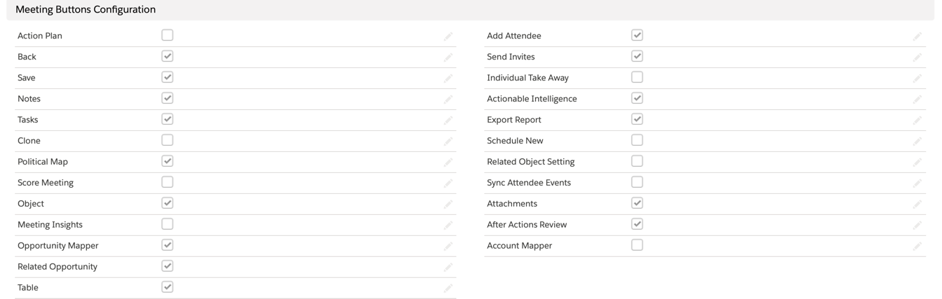
Figure 34

Back (default) - Takes you back to the associated Salesforce object (e.g. Opportunity)

Save (default) - Saves the current meeting information.

Notes (default) - Allows you to take meeting notes and view notes from previous meetings associated with this object (e.g. Opportunity).

Tasks (default) - Allows you to assign tasks to meeting attendees. These are standard Salesforce tasks.

Clone (default) - Allows you to create a new meeting clone of the current meeting. Ensure you change the name of the new meeting, buy default it will have the same title.

Political Map/Org Map (default) - Gives the ability to display and manipulate the organizational hierarchy of the customer/partner organizations

Score Meeting (default) – No longer used in Meeting Mapper.

Object (default) – Reserved for future use.

Meeting Insights - Allows you to specify from a list of items what resonated in a meeting.

Opportunity Mapper - Takes the user to the associated Opportunity Mapper page.

Related Opportunity - Allows the user to update an additional opportunity in a meeting.

NOTE – If you make edits to the fields selected, they will not affect current meetings using the template, only new meetings.

Table – Allows you to specify the table displayed on the meeting page, by default no table is displayed on the meeting page.

Add Attendee (default) - Add an attendee to the meeting, both contacts (customer team) and users (account team).

Send Invites (default) - Allows you the ability to send meeting invitations and include meeting agendas.

Individual Take Away (default) - Allows you to specify "take aways" for each meeting attendee.

Actionable Intelligence (default) - Allows the user to collect information about the Opportunity, Account, etc.

Export Report (default) - Allows you to export a public and internal meeting report.

Schedule New (default) - Allows you to create and schedule a new meeting.

Related Object Settings (default) - Allows the ability to populate fields.

Sync Attendee Events (default) - This pulls forward tasks from previous meetings that have not been completed.

Attachments (default) - Allows you to attach items as part of the meeting record.

After Actions Review (default) - Allows you to specify and describe a follow up item after the meeting.

Account Mapper - Takes the user to the Account Mapper page associated with the meeting.

Meeting Template Button Configuration Examples

Here are some button configuration Point N Time Software use in their meeting templates.

Leads (figure 35)

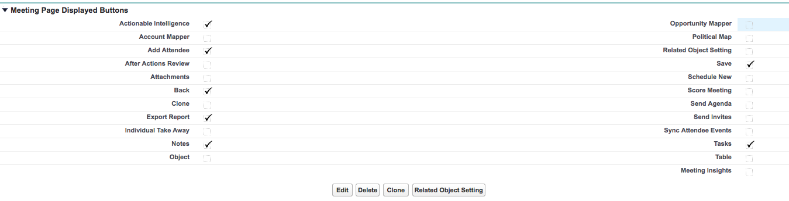
Figure 35

Accounts (figure 36)

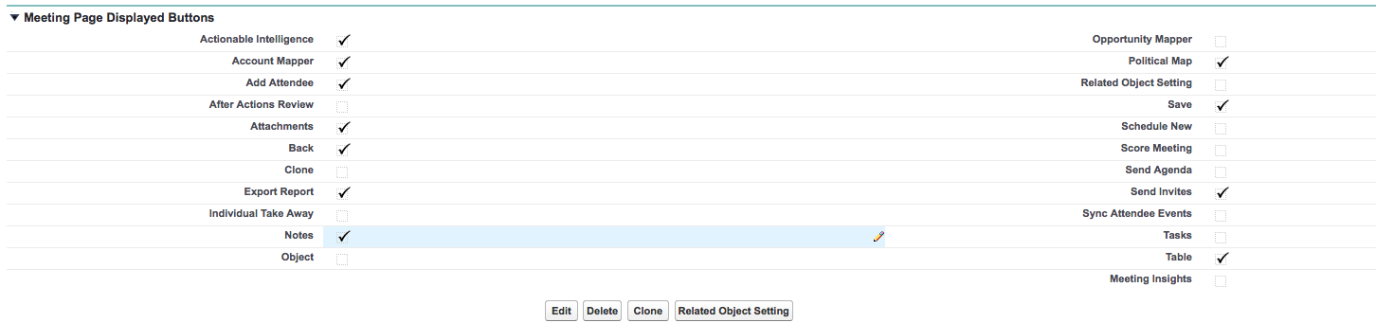
Figure 36

Opportunities (see figure 37)

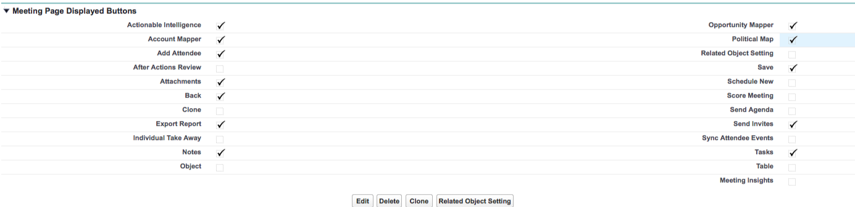
Figure 37

Cases (see figure 38)

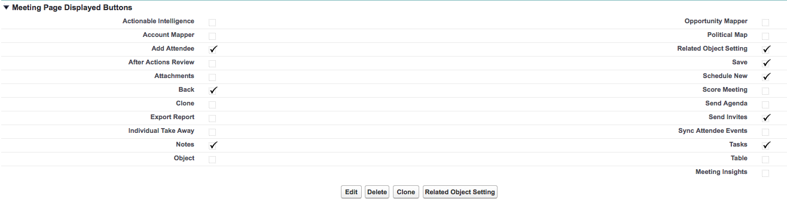
Figure 38

Campaigns (figure 39)

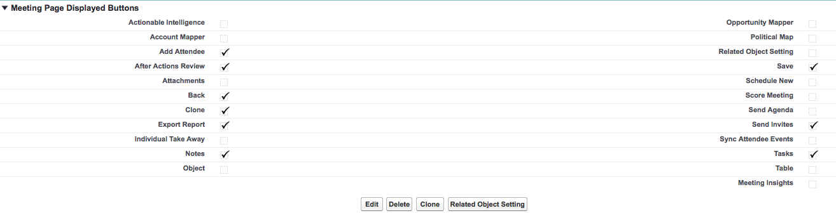
Figure 39

Meeting Insights

Meeting Insights is a great way to capture what is resonating in customer meetings. Meeting Insights are linked to individual templates and there is a maximum of ten that can be linked to a template (figure 40).

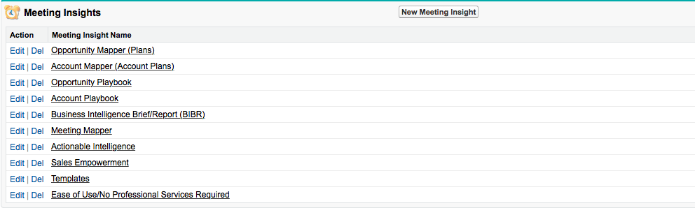
Figure 40

Only Meeting Insight Name must be completed for each Meeting Insight (figure 41).

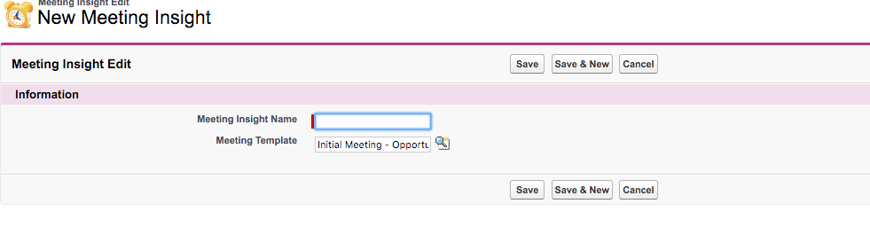
Figure 41

Meeting Prerequisites

Meeting Prerequisites allow you to specify task(s) or information that must be performed before the meeting (figure 42).

Figure 42

There are two fields that must be completed.

Meeting Prerequisites Name – select from the dropdown.

Prerequisites – additional information regarding the meeting prerequisite (figure 43).

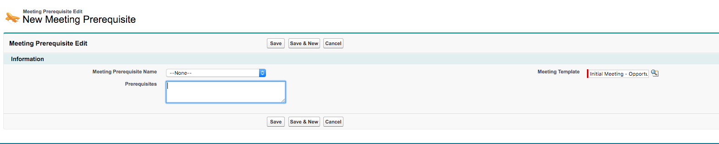
Figure 43

After Actions Review

After Actions Review allows you to discuss critical items after an opportunity has closed (figure 44). The review will be linked to the opportunity.

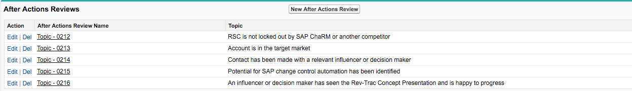
Figure 44

Follow Up

Follow Up allows you to configure tasks that are required after a meeting is completed. This ensures teams are following up with prospects and customers after meetings (figure 45). Follow Up also creates an event/task in Salesforce and is placed on the users Salesforce calendar.

Figure 45

There are 7 fields with 6 needing completed for each Follow Up (figure 46). They are:

Sequence – indicate numerically the order Follow Up must be completed.

Follow Up – select the follow up from the picklist.

Details – included any additional details to the user

Meeting Template – prepopulated

How Long – indicated numerically how long after the meeting is complete the Follow Up must be completed by the user.

How Long Type – select either hours or days. This works in conjunction with How Long. For example; you select 1 in How Long and day in How Long Type.

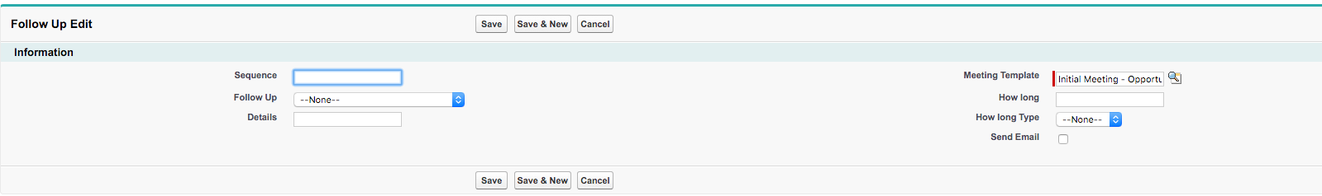
Figure 46

Objectives

“Objectives” allows you to prepopulate the objectives of the meeting for the user (figure 47).

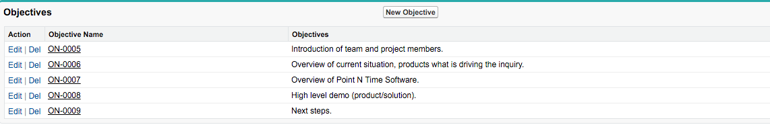
Figure 47

There is only one field required for an Objective. This should be a detailed description of the objective (figure 48).

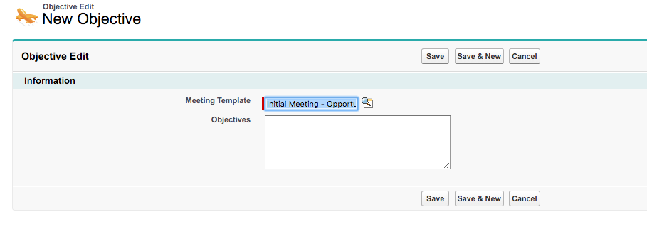
Figure 48

Pick List Values

The following picklist values are default values and examples of what can be added based on your business requirements. Add your values in the Your Configuration section of the table below. They can be cut and pasted into Strategy Mapper.

NOTE – Items in red should not be modified. Items lined through are not used in the current version and are reserved for later versions.

Meeting Mapper Picklist Configuration
Object | Field | Default Values | Your Configuration
Actionable Intelligence | Actions | Produce test template  Secure Sign off for contracts  Complete Product RFI/RFP  General Interest  Install in Production  Send Proposal  Schedule a Demo
 | Budgeted Project | Yes  No  Not Determined  Next FQ  Next FY
 | Decisions | Determine Pilot site  Move forward  Not to move forward  Evaluate other vendors  Do nothing
 | Reference Customer | Yes  No  Contact after deployment
Meeting Attendee Event | Type | Action Item  Next Step  Schedule Meeting  Phone  Send Pricing  Send Contracts  Schedule Dinner  Schedule Lunch  Schedule Outing
Meeting Attendee | Define Against | Did not meet requirements  Is Champion for competitor  Said will not support  Shows no interest  Indicated No Support
 | Level of Participation | Non-Interactive  Confrontational  Distracted  Interactive  Very Interactive
 | Defined Champion | Gave me competitive information  Will take a call anytime  Gives me frequent updates  Got 1 - on - 1 meeting with Executives  Brought us into account
 | Role | Account Executive  Board Member  Buyer  Candidate  Chairman of the Board  Champion  Consultant  Decision Maker  Director  Economic Buyer  Employee  Evaluator  Executive Sponsor  Facilitator  Finance  Gatekeeper  Human Resources  Instructor  Interviewer  Legal  Manager  Marketing  Mentor/Coach  Moderator  Participant Proxy  Partner  Presenter  Product Marketing  Product Manager  Project Owner  Purchasing Agent  System/Sales Engineer  Technical Buyer  Trusted Advisor  Unknown  Vendor(Supplier)  Influencer
 | Defined For | Said will buy  Leading with our solution  Executive Sponsor in account  Recommending our solution  Will sign off on PO
 | Stance | Against  For  Neutral  No Show  Participant  Undecided
Customer Requirement | Product Type | Recently Products  Search Product  Not Listed
 | Our Solution | Partner Product/Solution  Meets Requirement  Partially meets requirement  On roadmap  Does not meeting requirement(s)
Competitor | Competitor
Follow Up | Follow Up | Send Thank You email  Send Follow up Hand Written Note  Schedule next meeting
 | How Long | Hours  Days
Meeting Prerequisites | Meeting Prerequisites Name | Pre-Demo Contact  Project Charter  Send invites to project members  Verify Contracts  RainKing  Check Hoovers  LinkedIn  Ensure you have current PowerPoint
Meeting | Conference Type | GoToMeeting  Hangouts  Other  UberConference  WebEx  Skype  Join.Me  None
 | Add Objectives | 1
 | Repeat | Daily  Weekly  Monthly  Yearly  Every Two Weeks  Every Quarter  Every Six Months
 | Score Meeting | 5  4  3  2  1 | Not used in current version – replaced with slider on meeting page.
 | Stage | Prospecting  Qualification  Needs Analysis  Value Proposition  Id. Decision Makers  Perception Analysis  Proposal/Price Quote  Negotiation/Review  Closed Won  Closed Lost | Meeting Mapper – Do not modify here, this list is prepopulated from Salesforce.
 | Table Shape | Cloud  Circle  Oval  Rectangle  No Table
 | Type | Remote  On-Site  Corporate Headquarters  Conference  Executive Briefing Center  Outside Sales Set  Referral  Upcall  Cold Call
 | Object | Not Used in this version
Objections | Objections to Overcome | Not a priority  Don't see a need at this time  Not funded (no budget)  No resources
Obstacles | Obstacles to Win | Not a priority  Don't see a need at this time  Not funded (no budget)  No resources
Pain Points | Pain Points | Not a priority  Don't see a need at this time  Not funded (no budget)  No resources
Strengths | Our Strengths | Incumbent  Reference Customer  Relationships at the C-Level  5 Star rated on AppExchange  Configurable solution  Support
Weaknesses | Our Weaknesses | Not Incumbent  Reference customer for competition  No support for Android  Small company
Why Buys | Why Buys | Pressure from executive team  Increase sales by 10%  Reduce cost of sales by 15%

